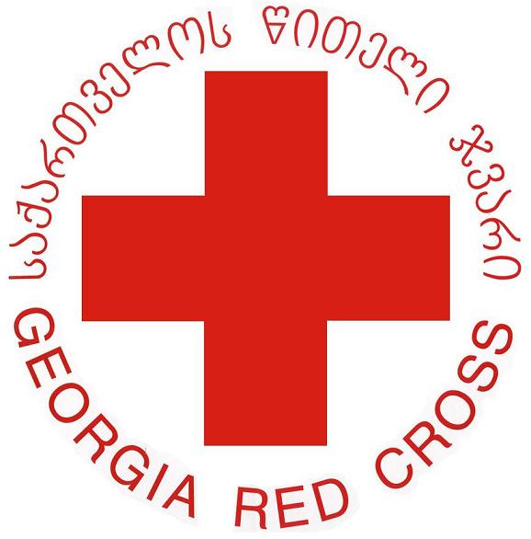
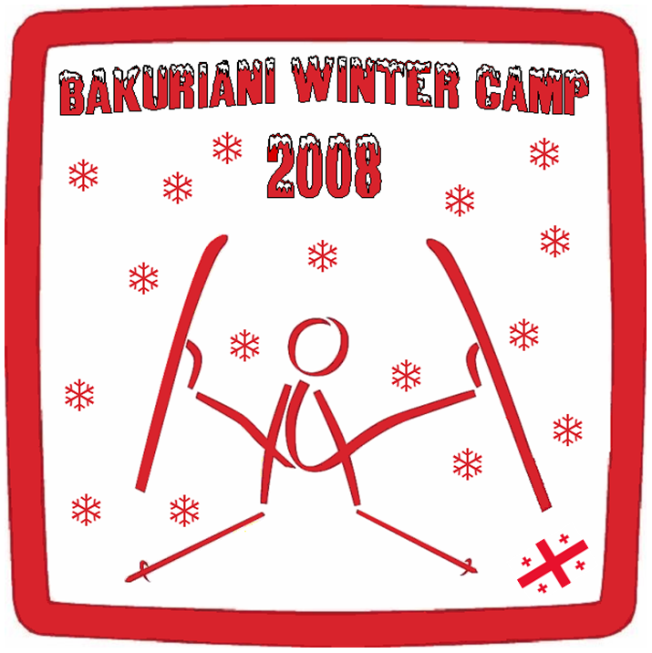
GEORGIA RED CROSS SOCIETY

International Youth Winter camp 2008
Bakuriani/ Georgia

Invitation to the International Youth Winter Camp organized by Georgia Red Cross Society, Bakuriani/Georgia 18-24 February 2008.

Dear all,

On behalf of Georgia Red Cross Society we would like to inform you that the Youth Department of GRCS is in new and complicating process of development. Our future plans and wills are to form close relations and establish co-ordination with youth departments of all NS-s. Also we desire to raise funds for our capacity building to organize youth-oriented actions properly. To reach this two particular goals, our department is organizing International Youth Winter Camp for young volunteers of RC/RC societies in the most beautiful mountainous winter resort of Georgia on 18-24 February.

Georgia Red Cross Society will be extremely delighted if you kindly accept our invitation and send motivated volunteer(s) of your society. By doing this you will greatly assist our strong will of development. On behalf of our Society we promise camp participants to have great fun and spend unforgettable six days in Georgia.

After the arrival of your delegation in Tbilisi / Georgia we will have the pleasure to take care for the shuttle, accommodation and the program of your delegates. The camp language will be English.

In view of a considerable preparation for the event, we kindly ask you to send the registration form within the deadline of 15th January 2008. We are looking forward to host the members of your National Society in Georgia.

For any further questions, please do not hesitate to contact us by phone or e-mail.

Best regards

Mr. Lado MARJANIDZE Ms. NINO SKHIRTLADZE
Youth Affairs Officer Project Coordinator

ADDRESS: 15 KRILOV STREET, 0102, TBILISI, GEORGIA
PHONE: 995 32 96 15 34
FAX: 995 32 96 06 98
E-MAİL: press@redcross.ge
project Coordinator: nskhirtladze@redcross.ge

